**Assignment -1**

**Looping Statements -**

**1. Print “*” Pattern as**

**Input-**

**\***

**\*\***

**\*\*\***

**\*\*\*\***

**\*\*\*\*\***

Input:-

using System;

using System.Collections.Generic;

using System.Linq;

using System.Text;

namespace ConsoleApplication1{

class Num_Pattern{

static void Main(string[] args){

int i = 0, j = 0;

for (i = 1; i <= 5; i++){

Console.WriteLine("");

for (j = 1; j <= i; j++){

Console.Write("*");

}

}

Console.ReadLine();

}

}

}

**Output:-**

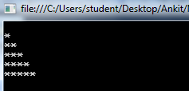

**2. Print No. Pattern as-**

**1**

**22**

**333**

**4444**

**55555**

**Input:-**

using System;

using System.Collections.Generic;

using System.Linq;

using System.Text;

namespace ConsoleApplication1{

class Num_Pattern{

static void Main(string[] args){

int i = 0, j = 0;

for (i = 1; i <= 5; i++){

Console.WriteLine("");

for (j = 1; j <= i; j++){

Console.Write(i);

}

}

Console.ReadLine();

}

}

}

**Output:-**

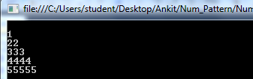

**3. Print No. Pattern as-**

**1**

**12**

**123**

**1234**

**12345**

**Input:-**

using System;

using System.Collections.Generic;

using System.Linq;

using System.Text;

namespace ConsoleApplication1

{

class Num_Pattern{

static void Main(string[] args){

int i = 0, j = 0;

for (i = 1; i <= 5; i++){

Console.WriteLine("");

for (j = 1; j <= i; j++){

Console.Write(j);

}

}

Console.ReadLine();

}

}

}

**Output:-**

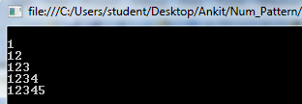

**4. Write a program for grades using switch case statement**

**Input:-**

using System;

using System.Collections.Generic;

using System.Linq;

using System.Text;

namespace ConsoleApplication14{

class Vowel{

static void Main(string[] args){

Console.WriteLine("enter an Alphabate");

char c = Convert.ToChar(Console.ReadLine());

switch (c){

case 'A':

Console.WriteLine("it is a vowel");

break;

case 'E':

Console.WriteLine("it is a vowel");

break;

case 'I':

Console.WriteLine("it is a vowel");

break;

case 'O':

Console.WriteLine("it is a vowel");

break;

case 'U':

Console.WriteLine("it is a vowel");

break;

case 'a':

Console.WriteLine("it is a vowel");

break;

case 'e':

Console.WriteLine("it is a vowel");

break;

case 'i':

Console.WriteLine("it is a vowel");

break;

case 'o':

Console.WriteLine("it is a vowel");

break;

case 'u':

Console.WriteLine("it is a vowel");

break;

default:

Console.WriteLine("it is not a vowel");

break;

}

Console.ReadLine();

}

}

}

Output:-

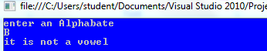

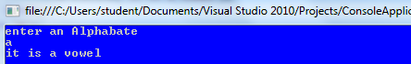

**Assingment-2**

**(Object Oriented, Functions and Method overloading)**

**1. Call by Value**

**Input:-**

using System;

using System.Collections.Generic;

using System.Linq;

using System.Text;

namespace ConsoleApplication1{

class Program{

public void show(int val){

val*=val;

Console.WriteLine("Value inside the show function "+val);

}

static void Main(string[] args){

int val = 50;

Program program = new Program();

Console.WriteLine("Value before calling the function: " + val);

program.show(val);

Console.WriteLine("Value after caliing the function: " + val);

Console.ReadLine();

}

}

}

**Output:-**

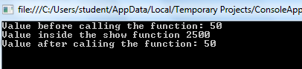

**2. Call by Reference**

**Input:-**

using System;

using System.Collections.Generic;

using System.Linq;

using System.Text;

namespace ConsoleApplication1{

class Program{

public void show(ref int val){

val*=val;

Console.WriteLine("Value inside the show function "+val);

}

static void Main(string[] args){

int val = 50;

Program program = new Program();

Console.WriteLine("Value before calling the function: " + val);

program.show(ref val);

Console.WriteLine("Value after caliing the function: " + val);

Console.ReadLine();

}

}

}

**Output:-**

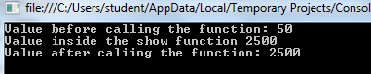

**3. Using "out" Parameter**

**Input:-**

using System;

using System.Collections.Generic;

using System.Linq;

using System.Text;

namespace ConsoleApplication1{

class Program{

public static void multiplication(out int val){

val = 10;

val*=val;

}

static void Main(string[] args){

int x;

multiplication(out x);

Console.WriteLine("{0}",x);

Console.ReadLine();

}

}

}

**Output:-**

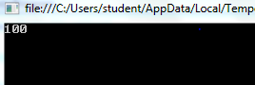

**4. Access Specifier**

**1. Public:**

**Input:-**

using System;

using System.Collections.Generic;

using System.Linq;

using System.Text;

namespace AccessSpecifier{

class PublicTest{

public string name = "Abc";

public void show(){

Console.WriteLine("welcome");

}

}

class Program{

static void Main(string[] args){

PublicTest test = new PublicTest();

Console.WriteLine("Hello " +test.name);

test.show();

Console.ReadLine();

}

}

}

**Output:-**

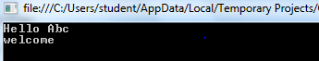

**2. Private:**

**Input:-**

using System;

using System.Collections.Generic;

using System.Linq;

using System.Text;

namespace AccessSpecifier{

class PublicTest{

public string name = "Abc";

public void show(){

Console.WriteLine("welcome");

}

}

class Program{

static void Main(string[] args){

PublicTest test = new PublicTest();

Console.WriteLine("Hello " +test.name);

test.show();

Console.ReadLine();

}

}

}

**Output:-**



**3. Protected:**

**Input:-**

using System;

using System.Collections.Generic;

using System.Linq;

using System.Text;

namespace AccessSpecifier{

class PublicTest{

public string name = "Abc";

public void show(){

Console.WriteLine("welcome");

}

}

class Program{

static void Main(string[] args){

PublicTest test = new PublicTest();

Console.WriteLine("Hello " +test.name);

test.show();

Console.ReadLine();

}

}

}

**Output:-**



**4. Addition of two numbers using user-defined function**

**Input:-**

using System;

using System.Collections.Generic;

using System.Linq;

using System.Text;

namespace ConsoleApplication1{

class Add_Sub{

static void Main(string[] args){

int first, second, result;

Console.WriteLine("Enter two numbers: ");

first = Convert.ToInt32(Console.ReadLine());

second = Convert.ToInt32(Console.ReadLine());

result = add(first, second);

Console.WriteLine("sum {0}", result);

Console.ReadLine();

}

public static int add(int a, int b){

int c;

c = a + b;

return c;

}

}

}

**Output:-**

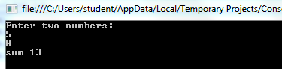

**Assignment-3**

**Design :-**

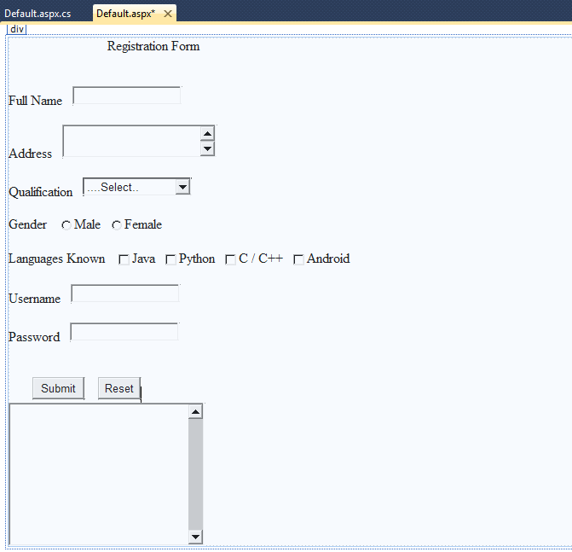

**Coding:**

**Default.aspx:**

<%@ Page Language="C#" AutoEventWireup="true" CodeFile="Default.aspx.cs" Inherits="_Default" %>

<!DOCTYPE html PUBLIC "-//W3C//DTD XHTML 1.0 Transitional//EN" "http://www.w3.org/TR/xhtml1/DTD/xhtml1-transitional.dtd">

<html xmlns="http://www.w3.org/1999/xhtml">

<head runat="server">

<title></title>

</head>

<body>

<form id="form1" runat="server">

<div>

&nbsp;&nbsp;&nbsp;&nbsp;&nbsp;&nbsp;&nbsp;&nbsp;&nbsp;&nbsp;&nbsp;&nbsp;&nbsp;&nbsp;&nbsp;&nbsp;&nbsp;&nbsp;&nbsp;&nbsp;&nbsp;&nbsp;&nbsp;&nbsp;&nbsp;&nbsp;&nbsp;&nbsp;

<asp:Label ID="lblTitle" runat="server" Text="Registration Form"></asp:Label>

<br />

<br />

<br />

<asp:Label ID="lblName" runat="server" Text="Full Name"></asp:Label>

&nbsp;&nbsp;

<asp:TextBox ID="txtName" runat="server"></asp:TextBox>

<br />

<br />

<asp:Label ID="lblAddr" runat="server" Text="Address"></asp:Label>

&nbsp;&nbsp;

<asp:TextBox ID="txtAddr" runat="server" Height="39px" TextMode="MultiLine"></asp:TextBox>

<br />

<br />

<asp:Label ID="lblQualification" runat="server" Text="Qualification"></asp:Label>

&nbsp;&nbsp;

<asp:DropDownList ID="ddlQualification" runat="server" AutoPostBack="True">

<asp:ListItem>....Select..</asp:ListItem>

<asp:ListItem>10th Passed</asp:ListItem>

<asp:ListItem>12th Passed</asp:ListItem>

<asp:ListItem>Under Graduation</asp:ListItem>

<asp:ListItem>Post Graduation</asp:ListItem>

<asp:ListItem>Ph.d.</asp:ListItem>

</asp:DropDownList>

<br />

<br />

<asp:Label ID="lblGender" runat="server" Text="Gender"></asp:Label>

&nbsp;&nbsp;

<asp:RadioButton ID="rbMale" runat="server" GroupName="gender" Text="Male" />

&nbsp;

<asp:RadioButton ID="rbFemale" runat="server" GroupName="gender"

Text="Female" />

<br />

&nbsp;<br />

<asp:Label ID="lblLanguage" runat="server" Text="Languages Known"></asp:Label>

&nbsp;&nbsp;

<asp:CheckBox ID="chkJava" runat="server" Text="Java" />

&nbsp;

<asp:CheckBox ID="chkPython" runat="server" Text="Python" />

&nbsp;

<asp:CheckBox ID="chkC" runat="server" Text="C / C++" />

&nbsp;

<asp:CheckBox ID="chkAndroid" runat="server" Text="Android" />

<br />

<br />

<asp:Label ID="lblUser" runat="server" Text="Username"></asp:Label>

&nbsp;&nbsp;

<asp:TextBox ID="txtUser" runat="server"></asp:TextBox>

<br />

<br />

<asp:Label ID="lblPassword" runat="server" Text="Password"></asp:Label>

&nbsp;&nbsp;

<asp:TextBox ID="txtPassword" runat="server" TextMode="Password"></asp:TextBox>

<br />

<br />

<br />

&nbsp;&nbsp;&nbsp;&nbsp;&nbsp;&nbsp;

<asp:Button ID="btnSubmit" runat="server" onclick="btnSubmit_Click"

Text="Submit" />

&nbsp;&nbsp;&nbsp;

<asp:Button ID="btnReset" runat="server" Text="Reset"

onclick="btnReset_Click" />

<br />

<asp:TextBox ID="txtMessage" runat="server" Height="216px" TextMode="MultiLine"

Width="230px"></asp:TextBox>

<br />

</div>

</form>

</body>

</html>

**Default.aspx.cs**

using System;

using System.Collections.Generic;

using System.Linq;

using System.Web;

using System.Web.UI;

using System.Web.UI.WebControls;

public partial class _Default : System.Web.UI.Page{

protected void Page_Load(object sender, EventArgs e){

}

protected void btnSubmit_Click(object sender, EventArgs e){

String name = "", addr = "", quali = "", gender = "", lang = "", uname = "", pwd = "";

name = txtName.Text;

addr = txtAddr.Text;

if (rbMale.Checked)

gender = "Male";

if (rbFemale.Checked)

gender = "Female";

if (chkJava.Checked)

lang = "Java";

if (chkPython.Checked)

lang += "Python";

if (chkC.Checked)

lang += "C / C++";

if (chkAndroid.Checked)

lang += "Android";

quali = ddlQualification.Text;

uname = txtUser.Text;

pwd = txtPassword.Text;

txtMessage.Text = "Name: " + name + " \nAddress: " + addr + " \nQulification: " + quali + " \nGender: " + gender + " \nLanguages known: " + lang + " \nUsername: " + uname + " \nPassword: " + pwd;

}

protected void btnReset_Click(object sender, EventArgs e){

txtName.Text = "";

txtAddr.Text = "";

rbMale.Checked = false;

rbFemale.Checked = false;

chkJava.Checked = false;

chkPython.Checked = false;

chkC.Checked = false;

chkAndroid.Checked = false;

txtUser.Text = "";

txtPassword.Text = "";

ddlQualification.SelectedIndex = 0;

txtMessage.Text = "";

}

}

**Output-**

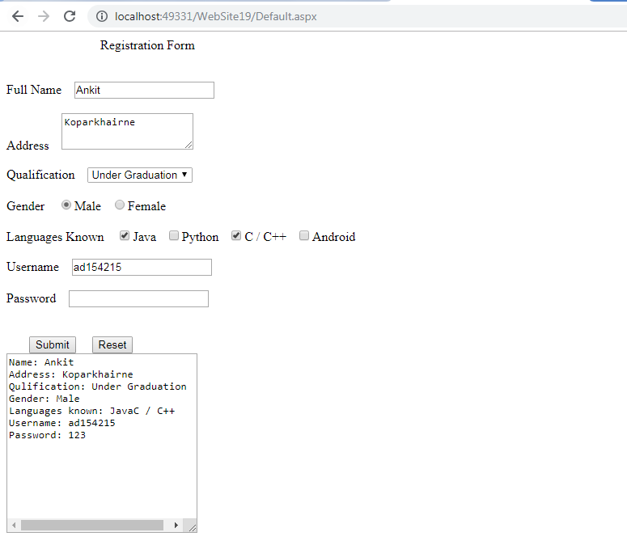

**Assignment-4**

**(State Management)**

**Server Side-**

**1. Session:**

**Input:-**

**Login.aspx:**

<%@ Page Language="C#" AutoEventWireup="true" CodeBehind="Login.aspx.cs" Inherits="WebApplication61.WebForm1" %>

<!DOCTYPE html PUBLIC "-//W3C//DTD XHTML 1.0 Transitional//EN" "http://www.w3.org/TR/xhtml1/DTD/xhtml1-transitional.dtd">

<html xmlns="http://www.w3.org/1999/xhtml">

<head runat="server">

<title></title>

</head>

<body>

<form id="form1" runat="server">

<div>

<asp:Label ID="lblUser" runat="server" Text="Username"></asp:Label>

&nbsp;&nbsp;&nbsp;

<asp:TextBox ID="txtUser" runat="server"></asp:TextBox>

<br />

<br />

<asp:Label ID="lblpwd" runat="server" Text="Password"></asp:Label>

&nbsp;&nbsp;&nbsp;

<asp:TextBox ID="txtpwd" runat="server"></asp:TextBox>

<br />

<br />

&nbsp;&nbsp;&nbsp;&nbsp;&nbsp;&nbsp;

<asp:Button ID="btnclick" runat="server" onclick="btnclick_Click"

Text="Click me" />

<br />

<br />

&nbsp;&nbsp;

<asp:Label ID="lblMessage" runat="server"></asp:Label>

</div>

</form>

</body>

</html>

**Home.aspx.cs**

<%@ Page Language="C#" AutoEventWireup="true" CodeBehind="Home.aspx.cs" Inherits="WebApplication61.WebForm2" %>

<!DOCTYPE html PUBLIC "-//W3C//DTD XHTML 1.0 Transitional//EN" "http://www.w3.org/TR/xhtml1/DTD/xhtml1-transitional.dtd">

<html xmlns="http://www.w3.org/1999/xhtml">

<head runat="server">

<title></title>

</head>

<body>

<form id="form1" runat="server">

<div>

<br /><br /> <br /><br /><br />

&nbsp;&nbsp;&nbsp;&nbsp;&nbsp;&nbsp;&nbsp;&nbsp;&nbsp;&nbsp;&nbsp;&nbsp;&nbsp;&nbsp;&nbsp;

<asp:Label ID="lblMessage" runat="server"></asp:Label>

<br /><br /> <br /><br /><br />

</div>

</form>

</body>

</html>

**Login.aspx.cs:**

using System;

using System.Collections.Generic;

using System.Linq;

using System.Web;

using System.Web.UI;

using System.Web.UI.WebControls;

namespace WebApplication61{

public partial class WebForm1 : System.Web.UI.Page{

protected void Page_Load(object sender, EventArgs e){

}

protected void btnclick_Click(object sender, EventArgs e){

if (txtUser.Text == "admin" && txtpwd.Text == "123"){

Session["user"] = txtUser.Text;

Response.Redirect("Home.aspx");

}

}

}

}

**Home.aspx.cs:-**

using System;

using System.Collections.Generic;

using System.Linq;

using System.Web;

using System.Web.UI;

using System.Web.UI.WebControls;

namespace WebApplication61{

public partial class WebForm2 : System.Web.UI.Page{

protected void Page_Load(object sender, EventArgs e){

if (Session["user"] != null){

lblMessage.Text = "Welcome " + Session["user"].ToString();

}

else{

Response.Redirect("Login.aspx");

}

}

}

}

**Output:-**

**Design:**

**Login.aspx:**

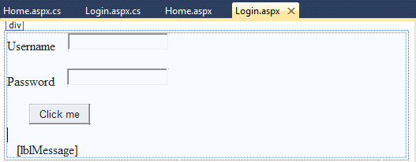

**Home.aspx:**

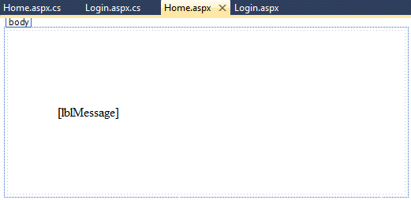

**Actual Output:-**

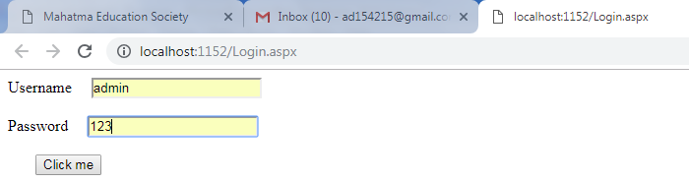

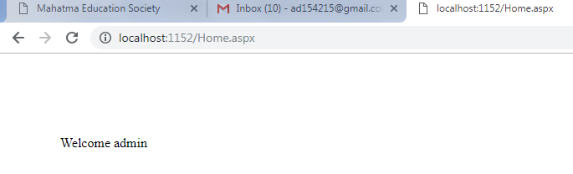

**2. Application:**

**Input:**

**Global.asax.cs :**

using System;

using System.Collections.Generic;

using System.Linq;

using System.Web;

using System.Web.Security;

using System.Web.SessionState;

namespace WebApplication62{

public class Global : System.Web.HttpApplication{

protected void Application_Start(object sender, EventArgs e){

Application["totalUser"] = 0;

Application["totalRequest"] = 0;

}

protected void Session_Start(object sender, EventArgs e){

Application.Lock();

Application["totalUser"] = Convert.ToInt32(Application["totalUser"].ToString()) + 1;

Application.UnLock();

}

protected void Application_BeginRequest(object sender, EventArgs e){

Application.Lock();

Application["totalRequest"] = Convert.ToInt32(Application["totalRequest"].ToString()) + 1;

Application.UnLock();

}

}

}

**Default.aspx :**

<%@ Page Language="C#" AutoEventWireup="true" CodeBehind="default.aspx.cs" Inherits="WebApplication62.WebForm1" %>

<!DOCTYPE html PUBLIC "-//W3C//DTD XHTML 1.0 Transitional//EN" "http://www.w3.org/TR/xhtml1/DTD/xhtml1-transitional.dtd">

<html xmlns="http://www.w3.org/1999/xhtml">

<head runat="server">

<title></title>

</head>

<body>

<form id="form1" runat="server">

<div>

<br />

<br />

&nbsp;&nbsp;&nbsp;&nbsp;&nbsp;&nbsp;&nbsp;&nbsp;&nbsp;&nbsp;&nbsp;&nbsp;&nbsp;

<asp:Label ID="lblTotaluser" runat="server" Text="Total User"></asp:Label>

<br />

<br />

&nbsp;&nbsp;&nbsp;&nbsp;&nbsp;&nbsp;&nbsp;&nbsp;&nbsp;&nbsp;&nbsp;&nbsp;&nbsp;

<asp:Label ID="lblTotalRequest" runat="server" Text="Total Request"></asp:Label>

<br />

</div>

</form>

</body>

</html>

**Default.aspx.cs :**

using System;

using System.Collections.Generic;

using System.Linq;

using System.Web;

using System.Web.UI;

using System.Web.UI.WebControls;

namespace WebApplication62{

public partial class WebForm1 : System.Web.UI.Page{

protected void Page_Load(object sender, EventArgs e){

lblTotaluser.Text = Application["totalUser"].ToString();

lblTotalRequest.Text = Application["totalRequest"].ToString();

}

}

}

**Ouput:**

**Design :**

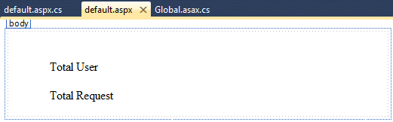

**Actual Output :**

**On chrome after 6 time refreshing.**

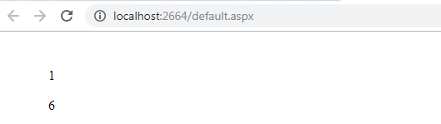

**At same time on Internet Explorer.**

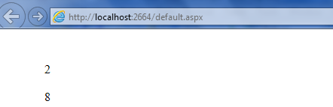

**Client Side-**

1. **ViewState :**

**Input:**

**WebForm1.aspx.cs file**

using System;

using System.Collections.Generic;

using System.Linq;

using System.Web;

using System.Web.UI;

using System.Web.UI.WebControls;

namespace WebApplication38{

public partial class WebForm1 : System.Web.UI.Page{

protected void Page_Load(object sender, EventArgs e){

}

protected void btnStart_Click(object sender, EventArgs e){

if (ViewState["count"] != null){

int i=Convert.ToInt32(ViewState["count"].ToString())+1;

lblMessage.Text=i.ToString();

ViewState["count"]=i.ToString();

}

else{

ViewState["count"]=1;

lblMessage.Text=ViewState["count"].ToString();

}

}

}

}

**WebForm1.aspx file**

<%@ Page Language="C#" AutoEventWireup="true" CodeBehind="WebForm1.aspx.cs" Inherits="WebApplication38.WebForm1" %>

<!DOCTYPE html PUBLIC "-//W3C//DTD XHTML 1.0 Transitional//EN" "http://www.w3.org/TR/xhtml1/DTD/xhtml1-transitional.dtd">

<html xmlns="http://www.w3.org/1999/xhtml">

<head runat="server">

<title></title>

</head>

<body>

<form id="form1" runat="server">

<asp:Button ID="btnStart" runat="server" onclick="btnStart_Click"

Text="Start" />

<br />

<div>

<asp:Label ID="lblMessage" runat="server"></asp:Label>

</div>

</form>

</body>

</html>

**Output:**

**Design:**

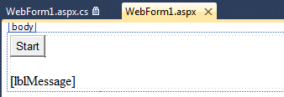

**Actual Output:**

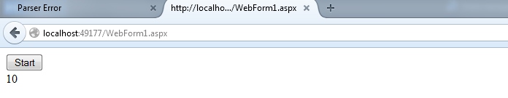

1. **Cookies :**

**Input:**

**WebForm2.aspx.cs:**

using System;

using System.Collections.Generic;

using System.Linq;

using System.Web;

using System.Web.UI;

using System.Web.UI.WebControls;

namespace WebApplication38{

public partial class WebForm2 : System.Web.UI.Page{

protected void Page_Load(object sender, EventArgs e){

}

protected void btnCreate_Click(object sender, EventArgs e){

Response.Cookies["user"].Value = txtCreate.Text;

Response.Cookies["user"].Expires = DateTime.Now.AddMinutes(2);

txtCreate.Text = "";

}

protected void btnRetrieve_Click(object sender, EventArgs e){

if (Request.Cookies["user"] != null){

txtRetrieve.Text = Request.Cookies["user"].Value;

}

else{

txtRetrieve.Text = "Cookies not found";

}

}

}

}

**WebForm.aspx:**

<%@ Page Language="C#" AutoEventWireup="true" CodeBehind="WebForm2.aspx.cs" Inherits="WebApplication38.WebForm2" %>

<!DOCTYPE html PUBLIC "-//W3C//DTD XHTML 1.0 Transitional//EN" "http://www.w3.org/TR/xhtml1/DTD/xhtml1-transitional.dtd">

<html xmlns="http://www.w3.org/1999/xhtml">

<head runat="server">

<title></title>

</head>

<body>

<form id="form1" runat="server">

<asp:Button ID="btnCreate" runat="server" onclick="btnCreate_Click"

Text="Create Cookie" />

&nbsp;&nbsp;&nbsp;&nbsp;&nbsp;&nbsp;&nbsp;

<asp:TextBox ID="txtCreate" runat="server"></asp:TextBox>

&nbsp;<div>

<br />

<asp:Button ID="btnRetrieve" runat="server" onclick="btnRetrieve_Click"

Text="Retrieve Cookie" />

&nbsp;&nbsp;&nbsp;&nbsp;

<asp:TextBox ID="txtRetrieve" runat="server"></asp:TextBox>

</div>

</form>

</body>

</html>

**Output:**

**Creating cookie:**

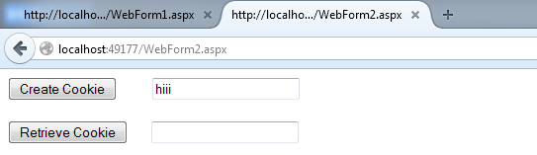

**Retrieving cookie:**

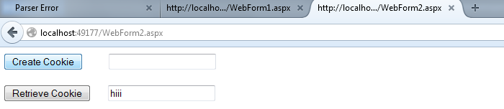

**Retrieving After 2 minutes:**

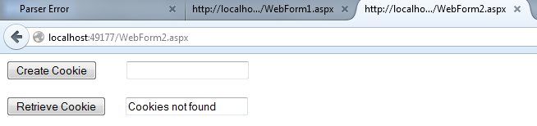

1. **Query String :-**

**Input:**

**First.aspx:**

<%@ Page Language="C#" AutoEventWireup="true" CodeBehind="first.aspx.cs" Inherits="WebApplication38.WebForm1" %>

<!DOCTYPE html PUBLIC "-//W3C//DTD XHTML 1.0 Transitional//EN" "http://www.w3.org/TR/xhtml1/DTD/xhtml1-transitional.dtd">

<html xmlns="http://www.w3.org/1999/xhtml">

<head runat="server">

<title></title>

</head>

<body>

<form id="form1" runat="server">

<asp:Label ID="lbluname" runat="server" Text="Username"></asp:Label>

&nbsp;&nbsp;&nbsp;&nbsp;&nbsp;&nbsp;&nbsp;

<asp:TextBox ID="txtuser" runat="server"></asp:TextBox>

<br />

<br />

<asp:Button ID="btnSubmit" runat="server" onclick="btnSubmit_Click"

Text="Submit" />

</form>

</body>

</html>

**First.aspx.cs :**

using System;

using System.Collections.Generic;

using System.Linq;

using System.Web;

using System.Web.UI;

using System.Web.UI.WebControls;

namespace WebApplication38{

public partial class WebForm1 : System.Web.UI.Page{

protected void Page_Load(object sender, EventArgs e){

}

protected void btnSubmit_Click(object sender, EventArgs e){

Response.Redirect("second.aspx?user=" + txtuser.Text);

}

}

}

**Second.aspx:**

<%@ Page Language="C#" AutoEventWireup="true" CodeBehind="second.aspx.cs" Inherits="WebApplication38.WebForm2" %>

<!DOCTYPE html PUBLIC "-//W3C//DTD XHTML 1.0 Transitional//EN" "http://www.w3.org/TR/xhtml1/DTD/xhtml1-transitional.dtd">

<html xmlns="http://www.w3.org/1999/xhtml">

<head runat="server">

<title></title>

</head>

<body>

<form id="form1" runat="server">

<div>

&nbsp;&nbsp;&nbsp;&nbsp; Hello

<asp:Label ID="lblMessage" runat="server" Text="________________"></asp:Label>

<br />

<br />

&nbsp;&nbsp;

<asp:Button ID="btnShow" runat="server" onclick="btnShow_Click" Text="Show" />

</div>

</form>

</body>

</html>

**Second.aspcx.cs :**

using System;

using System.Collections.Generic;

using System.Linq;

using System.Web;

using System.Web.UI;

using System.Web.UI.WebControls;

namespace WebApplication38{

public partial class WebForm2 : System.Web.UI.Page{

protected void Page_Load(object sender, EventArgs e){

}

protected void btnShow_Click(object sender, EventArgs e){

String str = Request.QueryString["user"];

lblMessage.Text = str;

}

}

}

**Output:**

**Design:**

**First.aspx:**

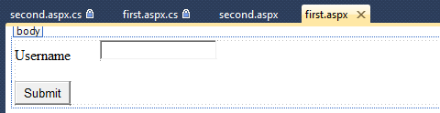

**Second.aspx :**

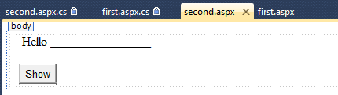

**Actual Output:**

**First page:**

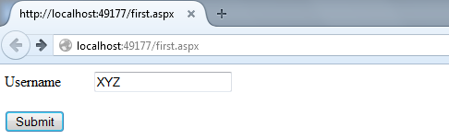

**After clicking on Submit button it calls to Second page.**

**Second Page:**

**After clicking on show, it fetches data from first page**

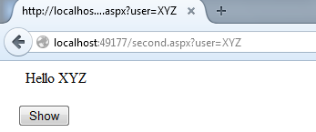

**Assignment -5**

**(Registration Form Validation)**

**Html Code:-**

<%@ Page Language="C#" AutoEventWireup="true" CodeBehind="WebForm1.aspx.cs" Inherits="WebApplication2.WebForm1" %>

<!DOCTYPE html>

<html xmlns="http://www.w3.org/1999/xhtml">

<head runat="server">

<title></title>

</head>

<body>

<form id="form1" runat="server">

<div style="height: 781px">

<div>

<asp:Label ID="Label1" runat="server" Text="First Name"></asp:Label>

&nbsp;<asp:TextBox ID="txtname" runat="server"></asp:TextBox>

<asp:RequiredFieldValidator ID="RequiredFieldValidator1" runat="server" ControlToValidate="txtname" ErrorMessage=" First name can not be blank"></asp:RequiredFieldValidator>

</div>

<asp:Label ID="Label2" runat="server" Text="Last Name"></asp:Label>

<asp:TextBox ID="txtlast" runat="server"></asp:TextBox>

<asp:RequiredFieldValidator ID="RequiredFieldValidator3" runat="server" ControlToValidate="txtlast" ErrorMessage="Last name can not be blank" ForeColor="Black"></asp:RequiredFieldValidator>

<br />

<asp:Label ID="Label3" runat="server" Text="Date of Birth"></asp:Label>

&nbsp;

<asp:TextBox ID="txtdob" runat="server"></asp:TextBox>

<asp:RequiredFieldValidator runat="server" ControlToValidate="txtdob" ErrorMessage="Date of Birth can not be blank" ID="RequiredFieldValidator6"></asp:RequiredFieldValidator>

&nbsp;&nbsp;&nbsp;&nbsp;&nbsp;&nbsp;&nbsp;&nbsp;&nbsp;&nbsp;&nbsp;&nbsp;&nbsp;&nbsp;&nbsp;&nbsp;&nbsp;&nbsp;&nbsp;&nbsp;&nbsp;&nbsp;&nbsp;&nbsp;&nbsp;&nbsp;&nbsp;&nbsp;&nbsp;&nbsp;&nbsp;&nbsp;

<br />

<asp:Label ID="lableage" runat="server" Text="Age"></asp:Label>

&nbsp;<asp:TextBox ID="txtage" runat="server"></asp:TextBox>

&nbsp;<asp:RangeValidator ID="RangeValidator1" runat="server" ControlToValidate="txtage" ErrorMessage="Age should be in 18 to 30" MaximumValue="30" MinimumValue="18"></asp:RangeValidator>

&nbsp;&nbsp;&nbsp;&nbsp;&nbsp;&nbsp;&nbsp;&nbsp;&nbsp;&nbsp;&nbsp;&nbsp;&nbsp;&nbsp;&nbsp;&nbsp;&nbsp;&nbsp;&nbsp;&nbsp;&nbsp;&nbsp;&nbsp;&nbsp;&nbsp;&nbsp;&nbsp;&nbsp;&nbsp;&nbsp;&nbsp;&nbsp;&nbsp;&nbsp;&nbsp;&nbsp;&nbsp;&nbsp;&nbsp;&nbsp;&nbsp;&nbsp;&nbsp;&nbsp;&nbsp;&nbsp;&nbsp;&nbsp;&nbsp;&nbsp;&nbsp;&nbsp;&nbsp;&nbsp;&nbsp;&nbsp;&nbsp;&nbsp;&nbsp;&nbsp;&nbsp;&nbsp;&nbsp;&nbsp;&nbsp;&nbsp;&nbsp;

<br />

<asp:Label ID="Label4" runat="server" Text="Email Id"></asp:Label>

<asp:TextBox ID="txtemail" runat="server"></asp:TextBox>

<asp:RegularExpressionValidator ID="RegularExpressionValidator1" runat="server" ErrorMessage="Please enter valid email Id" ControlToValidate="txtemail" ForeColor="Red" ValidationExpression="\w+([-+.']\w+)*@\w+([-.]\w+)*\.\w+([-.]\w+)*"></asp:RegularExpressionValidator>

&nbsp;<asp:RequiredFieldValidator ID="RequiredFieldValidator2" runat="server" ControlToValidate="txtemail" ErrorMessage="email can not be blank" ForeColor="#CC3399"></asp:RequiredFieldValidator>

<br />

<asp:Label ID="Label5" runat="server" Text="Mobile number"></asp:Label>

&nbsp;<asp:TextBox ID="txtmob" runat="server" ></asp:TextBox>

&nbsp;

<asp:RegularExpressionValidator ID="RegularExpressionValidator2" runat="server" ControlToValidate="txtmob" ErrorMessage="Please enter 10 digit mobile number" ForeColor="#9900FF" ValidationExpression="[0-9]{10}"></asp:RegularExpressionValidator>

<br />

<br />

<asp:Label ID="Label6" runat="server" Text=" "></asp:Label>

<asp:Label ID="Label7" runat="server" Text=" "></asp:Label>

<asp:Label ID="Label8" runat="server" Text="Gender"></asp:Label>

&nbsp;<asp:RadioButton ID="rbm" runat="server" Text=" " ValidationGroup="gender" />

male&nbsp;

<asp:RadioButton ID="rbf" runat="server" Text="female" ValidationGroup="gender" />

&nbsp;<br />

<br />

<asp:Label ID="Label9" runat="server" Text="Address"></asp:Label>

&nbsp;<asp:TextBox ID="txtadd" runat="server" style="margin-top: 0px"></asp:TextBox>

&nbsp;<asp:RequiredFieldValidator runat="server" ControlToValidate="txtadd" ErrorMessage="Please enter Address" ID="RequiredFieldValidator7"></asp:RequiredFieldValidator>

<br />

<asp:Label ID="Label10" runat="server" Text="City"></asp:Label>

&nbsp;<asp:TextBox ID="txtcity" runat="server"></asp:TextBox>

&nbsp;<asp:RequiredFieldValidator ID="RequiredFieldValidator4" runat="server" ControlToValidate="txtcity" ErrorMessage="Please enter a city"></asp:RequiredFieldValidator>

<br />

&nbsp;<asp:Label ID="Label11" runat="server" Text="Pin code"></asp:Label>

&nbsp;<asp:TextBox ID="txtpin" runat="server"></asp:TextBox>

&nbsp;

<asp:RegularExpressionValidator ID="RegularExpressionValidator3" runat="server" ControlToValidate="txtpin" ErrorMessage="Please enter valid pincode" ValidationExpression="^[0-9]{6}$"></asp:RegularExpressionValidator>

&nbsp;&nbsp;&nbsp;&nbsp;&nbsp;&nbsp;&nbsp;&nbsp;&nbsp;&nbsp;&nbsp;&nbsp;&nbsp;&nbsp;&nbsp;&nbsp;&nbsp;&nbsp;&nbsp;&nbsp;&nbsp;&nbsp;&nbsp;&nbsp;&nbsp;&nbsp;&nbsp;&nbsp;&nbsp;&nbsp;&nbsp;&nbsp;&nbsp;&nbsp;&nbsp;&nbsp;&nbsp;&nbsp;&nbsp;&nbsp;&nbsp;&nbsp;&nbsp;&nbsp;&nbsp;&nbsp;&nbsp;&nbsp;&nbsp;&nbsp;&nbsp;&nbsp;&nbsp;

<br />

<br />

<asp:Label ID="Label12" runat="server" Text="State"></asp:Label>

&nbsp;<asp:TextBox ID="txtstate" runat="server"></asp:TextBox>

&nbsp;<asp:RequiredFieldValidator ID="RequiredFieldValidator5" runat="server" ControlToValidate="txtstate" ErrorMessage="Please enter state"></asp:RequiredFieldValidator>

<br />

<p>

&nbsp;&nbsp;&nbsp;&nbsp;&nbsp;&nbsp;&nbsp;&nbsp;<asp:Button ID="Button1" runat="server" OnClick="Button1_Click" Text="Submit" style="height: 26px" />

&nbsp;&nbsp;&nbsp;&nbsp;&nbsp;&nbsp;&nbsp;&nbsp;&nbsp;<asp:Button ID="Button2" runat="server" Text="Clear" OnClick="Button2_Click" />

&nbsp;&nbsp;&nbsp;&nbsp;&nbsp;&nbsp;&nbsp;&nbsp;&nbsp;&nbsp;&nbsp;&nbsp;&nbsp;&nbsp;&nbsp;&nbsp;&nbsp;&nbsp;&nbsp;&nbsp;&nbsp;&nbsp;&nbsp;&nbsp;&nbsp;&nbsp;&nbsp;&nbsp;&nbsp;&nbsp;&nbsp;&nbsp;&nbsp;&nbsp;&nbsp;&nbsp;&nbsp;

</p>

<p>

Output:-</p>

<p>

&nbsp;

<asp:Label ID="output" runat="server" Text="Please fill all the detail :)"></asp:Label>

</p>

<p>

&nbsp;</p>

</div>

<p>

&nbsp;</p>

<p>

&nbsp;</p>

</form>

</body>

</html>

**C# Code:-**

using System;

using System.Collections.Generic;

using System.Linq;

using System.Web;

using System.Web.UI;

using System.Web.UI.WebControls;

namespace WebApplication2{

public partial class WebForm1 : System.Web.UI.Page{

protected void Page_Load(object sender, EventArgs e){

}

protected void Button1_Click(object sender, EventArgs e){

String gender="";

if(rbm.Checked){

gender="male";

}

if(rbf.Checked){

gender="female";

}

output.Text = "My name is " + "\r\n" + txtname.Text +"I Live in " + txtadd.Text + " " + txtcity.Text + " "

+ txtstate.Text + " " + txtpin.Text + "\r\n" +

" I born on" + txtdob.Text +

"\r\n" + " I am " + txtage.Text + "\r\n" + "old" +

" I am " + gender + "\r\n" +

"My mobile no is " + txtmob.Text +

"\nMy Email Id is " + txtemail.Text;

}

protected void Button2_Click(object sender, EventArgs e){

txtemail.Text = "";

txtdob.Text = "";

txtcity.Text = "";

txtname.Text = "";

txtmob.Text = "";

txtlast.Text = "";

txtage.Text = "";

txtpin.Text = "";

txtstate.Text = "";

txtadd.Text = "";

txtemail.Text = "";

output.Text = "";

}

}

}

**Output:-**

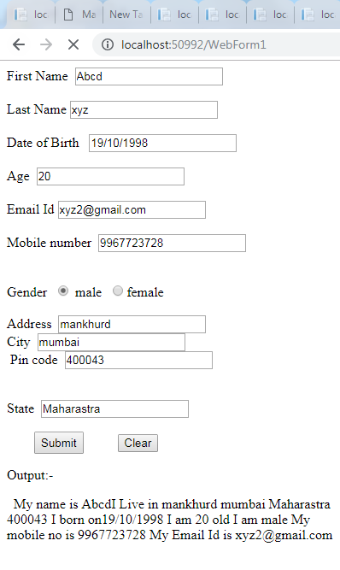

**Assignment No. 6**

**Rich Controls in .Net Technology**

1. **Calender Manager**

**Input :-**

**default.aspx :**

<%@ Page Language="C#" AutoEventWireup="true" CodeBehind="default.aspx.cs" Inherits="RichControls_Calender._default" %>

<!DOCTYPE html PUBLIC "-//W3C//DTD XHTML 1.0 Transitional//EN" "http://www.w3.org/TR/xhtml1/DTD/xhtml1-transitional.dtd">

<html xmlns="http://www.w3.org/1999/xhtml">

<head runat="server">

<title></title>

</head>

<body>

<form id="form1" runat="server">

<asp:Calendar ID="Calendar1" runat="server"

onselectionchanged="Calendar1_SelectionChanged"></asp:Calendar>

<br />

<asp:Label ID="lblTodayDate" runat="server"></asp:Label>

<br />

<br />

<asp:Label ID="lblSelectedDate" runat="server"></asp:Label>

<div>

</div>

</form>

</body>

</html>

**default.aspx.cs :**

using System;

using System.Collections.Generic;

using System.Linq;

using System.Web;

using System.Web.UI;

using System.Web.UI.WebControls;

namespace RichControls_Calender

{

public partial class _default : System.Web.UI.Page

{

protected void Page_Load(object sender, EventArgs e)

{

}

protected void Calendar1_SelectionChanged(object sender, EventArgs e)

{

lblTodayDate.Text = Calendar1.TodaysDate.ToShortDateString();

lblSelectedDate.Text = Calendar1.SelectedDate.ToShortDateString();

}

}

}

**Design :-**

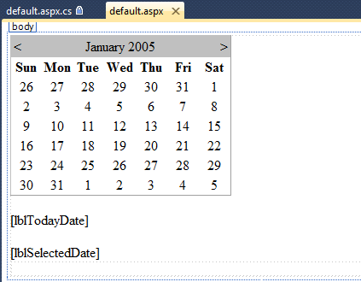

**Output :-**

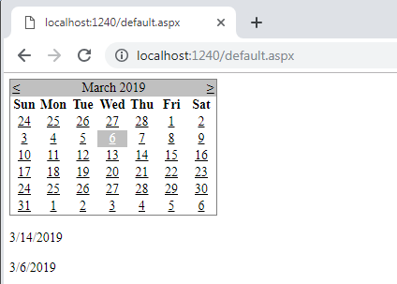

1. **AD Rotator**

**Input :-**

**WebForm1.aspx**

<%@ Page Language="C#" AutoEventWireup="true" CodeBehind="WebForm1.aspx.cs" Inherits="WebApplication7.WebForm1" %>

<!DOCTYPE html>

<html xmlns="http://www.w3.org/1999/xhtml">

<head runat="server">

<title></title>

</head>

<body>

<form id="form1" runat="server">

<div>

<asp:AdRotator runat = "server" AdvertisementFile = "XMLFile1.xml" />

</div>

</form>

</body>

</html>

**XMLFile1.xml**

<?xml version="1.0" encoding="utf-8" ?>

<Advertisements>

<Ad>

<ImageUrl>~/Images/bts.png</ImageUrl>

<NavigateUrl>https://www.google.co.in/</NavigateUrl>

<AlternateText> bts</AlternateText>

<Impressions> 10 </Impressions>

<Keyword> bts</Keyword>90

</Ad>

</Advertisements>

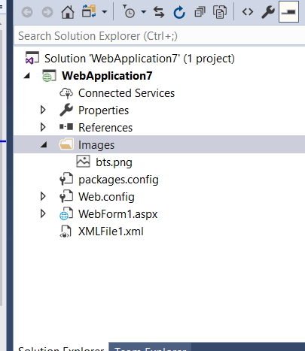

**Fig a : Images Folder in Solution Explorer**

**Output :-**



**Assignment No. 7**

**Database in ASP.Net Technology**

**Input:**

**Default.aspx:**

<%@ Page Language="C#" AutoEventWireup="true" CodeFile="Default.aspx.cs" Inherits="_Default" %>

<!DOCTYPE html>

<html xmlns="http://www.w3.org/1999/xhtml">

<head runat="server">

<title></title>

<style type="text/css">

.auto-style1 {

width: 100px;

}

.auto-style2 {

width: 149px;

}

.auto-style3 {

width: 114px;

}

.auto-style4 {

width: 148px;

}

</style>

</head>

<body>

<form id="form1" runat="server">

<div>

<table style="width: 100%; margin-top: 0px;">

<tr>

<td class="auto-style1">

<asp:Label ID="lblRollno" runat="server" Text="Rollno"></asp:Label>

</td>

<td class="auto-style2">

<asp:TextBox ID="txtRollno" runat="server"></asp:TextBox>

</td>

<td>&nbsp;</td>

</tr>

<tr>

<td class="auto-style1">

<asp:Label ID="lblName" runat="server" Text="Name"></asp:Label>

</td>

<td class="auto-style2">

<asp:TextBox ID="txtName" runat="server"></asp:TextBox>

</td>

<td>&nbsp;</td>

</tr>

<tr>

<td class="auto-style1">

<asp:Label ID="lblSurname" runat="server" Text="Surname"></asp:Label>

</td>

<td class="auto-style2">

<asp:TextBox ID="txtSurname" runat="server"></asp:TextBox>

</td>

<td>&nbsp;</td>

</tr>

</table>

<table style="width:100%;">

<tr>

<td class="auto-style3">&nbsp;</td>

<td class="auto-style4">

<asp:Label ID="lblMsg" runat="server"></asp:Label>

</td>

<td>&nbsp;</td>

</tr>

<tr>

<td class="auto-style3">

<asp:Button ID="btnSave" runat="server" OnClick="btnSave_Click" Text="Save" />

&nbsp;<asp:Button ID="btnUpdate" runat="server" OnClick="btnUpdate_Click" Text="Update" />

</td>

<td class="auto-style4">

<asp:Button ID="Button3" runat="server" OnClick="Button3_Click" Text="Delete" />

&nbsp;<asp:Button ID="btnShow" runat="server" OnClick="btnShow_Click" Text="Show" />

</td>

<td>&nbsp;</td>

</tr>

<tr>

<td class="auto-style3">&nbsp;</td>

<td class="auto-style4">&nbsp;</td>

<td>&nbsp;</td>

</tr>

</table>

<br />

&nbsp;</div>

</form>

</body>

</html>

**Default.aspx.cs :**

using System;

using System.Collections.Generic;

using System.Linq;

using System.Web;

using System.Web.UI;

using System.Web.UI.WebControls;

using System.Data.SqlClient;

public partial class _Default : System.Web.UI.Page

{

protected void Page_Load(object sender, EventArgs e)

{

}

protected void btnSave_Click(object sender, EventArgs e)

{

SqlConnection con = new SqlConnection(@"Data Source=(LocalDB)\v11.0;AttachDbFilename=C:\Users\Administrator\Documents\Visual Studio 2013\WebSites\WebSite1\App_Data\College.mdf;Integrated Security=True");

try

{

con.Open();

SqlCommand cmd = new SqlCommand("insert into student values(@Rollno,@Name,@Surname)",con);

cmd.Parameters.AddWithValue("@Rollno",Convert.ToInt32(txtRollno.Text));

cmd.Parameters.AddWithValue("@Name", txtName.Text);

cmd.Parameters.AddWithValue("@Surname", txtSurname.Text);

int result = cmd.ExecuteNonQuery();

if(result>0)

{

lblMsg.Text = "Record Saved";

}

else

{

lblMsg.Text = "Record can't saved";

}

}

catch(Exception exception)

{

lblMsg.Text = exception.Message;

}

finally{

con.Close();

}

}

protected void btnUpdate_Click(object sender, EventArgs e)

{

SqlConnection con = new SqlConnection(@"Data Source=(LocalDB)\v11.0;AttachDbFilename=C:\Users\Administrator\Documents\Visual Studio 2013\WebSites\WebSite1\App_Data\College.mdf;Integrated Security=True");

try

{

con.Open();

SqlCommand cmd = new SqlCommand("update student set Name=@name,Surname=@Surname where Rollno=@Rollno", con);

cmd.Parameters.AddWithValue("@Rollno", Convert.ToInt32(txtRollno.Text));

cmd.Parameters.AddWithValue("@Name", txtName.Text);

cmd.Parameters.AddWithValue("@Surname", txtSurname.Text);

int result = cmd.ExecuteNonQuery();

if (result > 0)

{

lblMsg.Text = "Record Updated";

}

else

{

lblMsg.Text = "Record can't Updated";

}

}

catch (Exception exception)

{

lblMsg.Text = exception.Message;

}

finally

{

con.Close();

}

}

protected void Button3_Click(object sender, EventArgs e)

{

SqlConnection con = new SqlConnection(@"Data Source=(LocalDB)\v11.0;AttachDbFilename=C:\Users\Administrator\Documents\Visual Studio 2013\WebSites\WebSite1\App_Data\College.mdf;Integrated Security=True");

try

{

con.Open();

SqlCommand cmd = new SqlCommand("delete from student where Rollno=@Rollno", con);

cmd.Parameters.AddWithValue("@Rollno", Convert.ToInt32(txtRollno.Text));

int result = cmd.ExecuteNonQuery();

if (result > 0)

{

lblMsg.Text = "Record Deleted";

}

else

{

lblMsg.Text = "Record can't Deleted";

}

}

catch (Exception exception)

{

lblMsg.Text = exception.Message;

}

finally

{

con.Close();

}

}

protected void btnShow_Click(object sender, EventArgs e)

{

SqlConnection con = new SqlConnection(@"Data Source=(LocalDB)\v11.0;AttachDbFilename=C:\Users\Administrator\Documents\Visual Studio 2013\WebSites\WebSite1\App_Data\College.mdf;Integrated Security=True");

try

{

con.Open();

SqlCommand cmd = new SqlCommand("select Name,Surname from student where Rollno=@Rollno", con);

cmd.Parameters.AddWithValue("@Rollno", Convert.ToInt32(txtRollno.Text));

SqlDataReader dr = cmd.ExecuteReader();

if (dr.Read())

{

txtName.Text = dr["Name"].ToString();

txtSurname.Text = dr["Surname"].ToString();

}

else

{

lblMsg.Text = "Data not found";

}

}

catch (Exception exception)

{

}

}

}

**Output :**

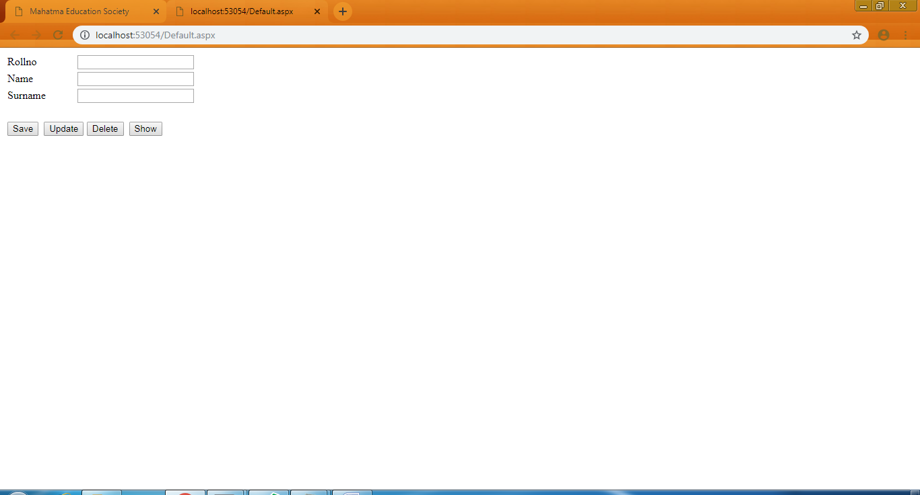

**For Save :**

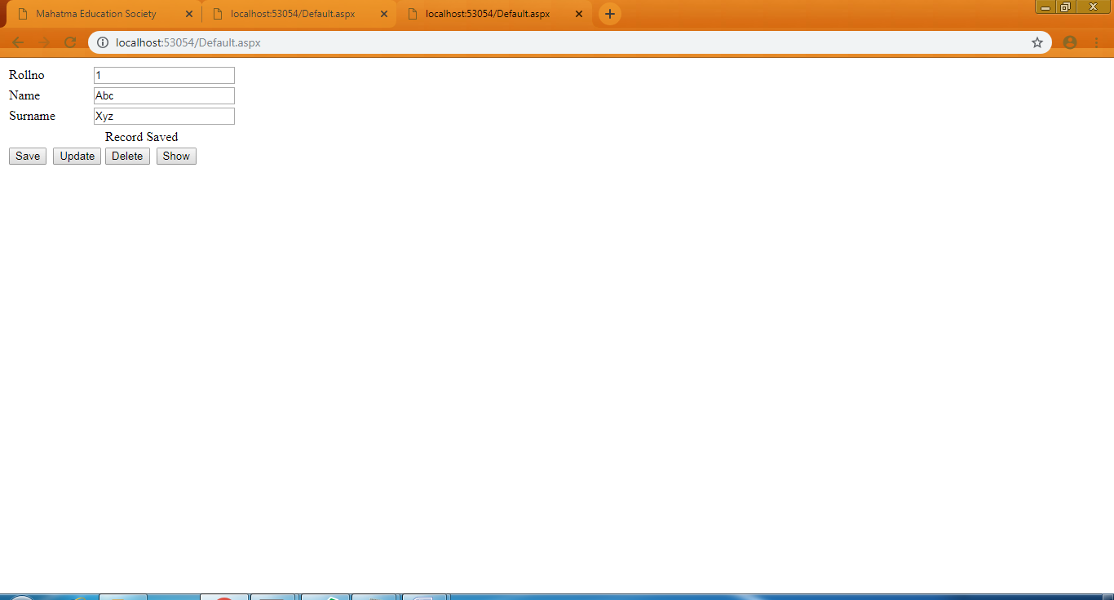

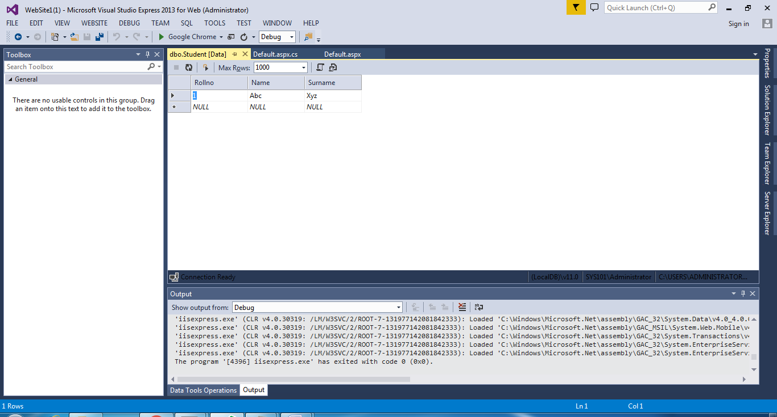

**For Update :**

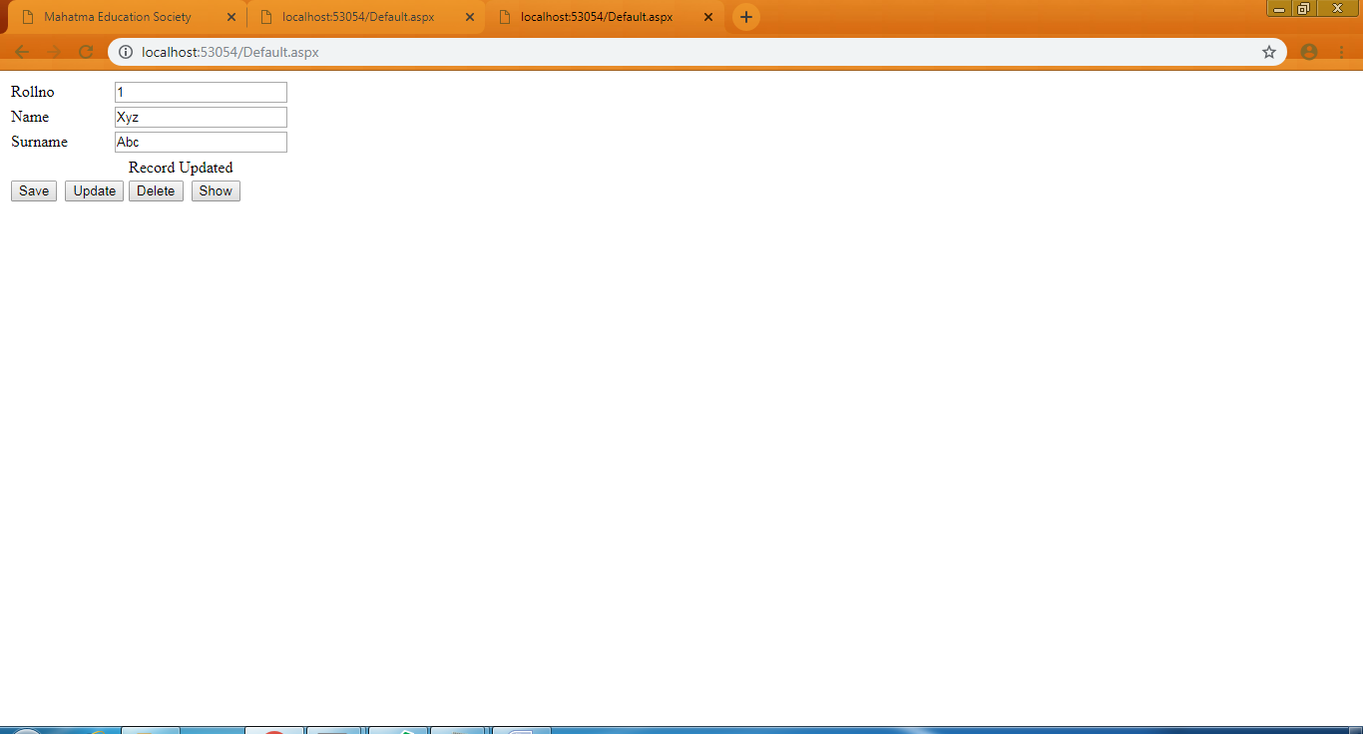

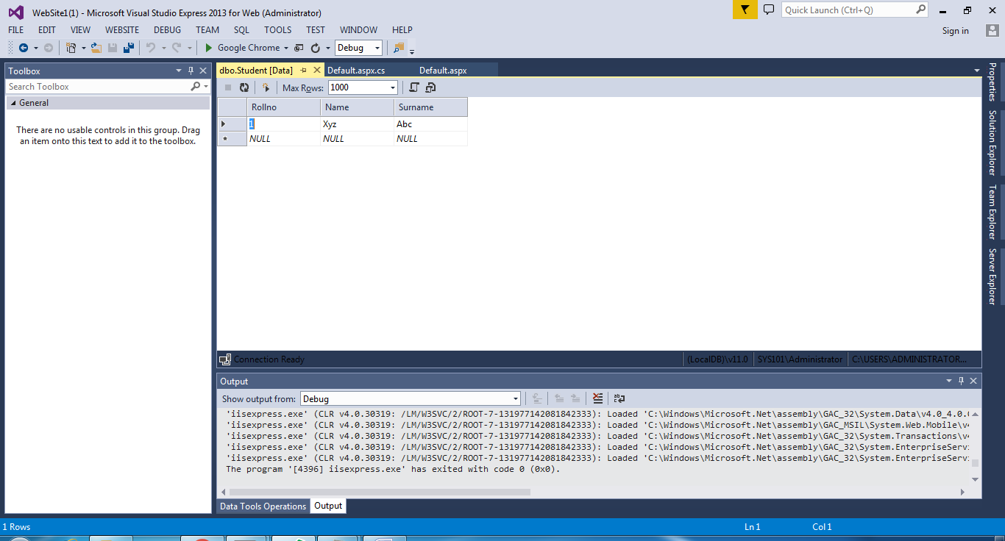

**For Show :**

**Enter only Roll no. Remaining fields will be filled automatically ☺**

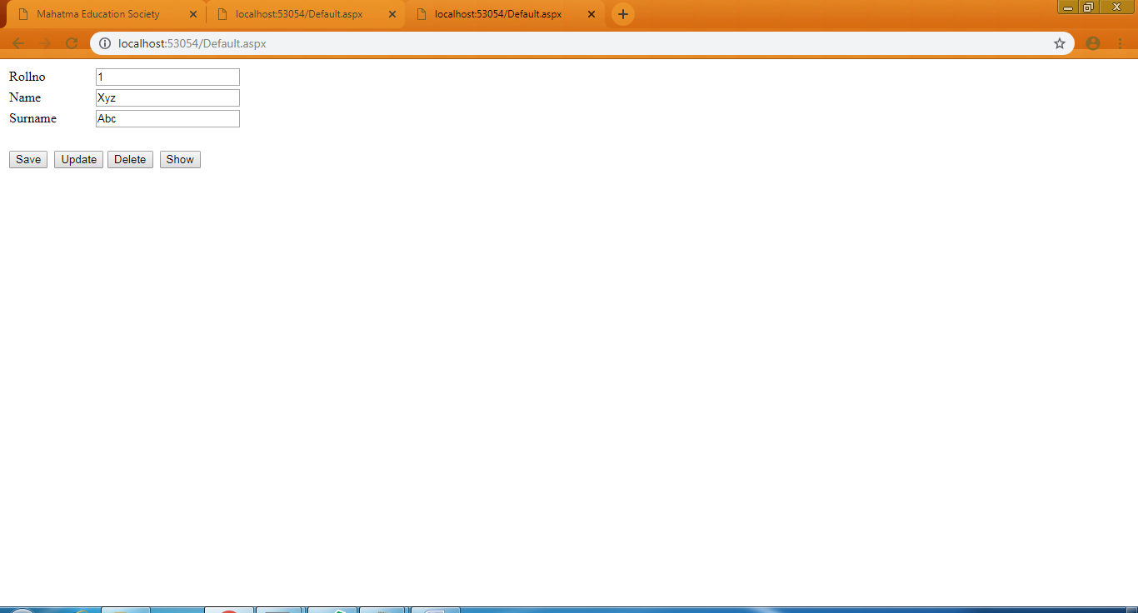

**For Delete :**

